⚖
LegalEase - AI Legal Document Generator
PROJECT DOCUMENTATION
Version 2.0 (Revised & Expanded)
September 2026

TEAM MEMBERS
- Anitha M (Team Leader)
- Swathi M
- Nithyasri M
- Pooja Shree P

1. Project Overview
LegalEase is an AI-powered legal document generator developed using Python. It provides a simple web interface where users can enter the document type, involved parties, terms and conditions, and effective date to generate a structured legal document.
The system uses Streamlit for the frontend, FastAPI for the backend API, and Google's Gemini 1.5 Pro model for AI-based document generation. Generated documents can be previewed, edited, and downloaded in TXT, DOCX, and PDF formats.

2. Objective
The main aim of this project is to build a simple and useful AI-assisted system that helps users generate structured legal documents from the information they provide.

3. Main Features
- AI-based Legal Document Generation
- User input for Document Type, Parties, Terms and Effective Date
- FastAPI REST endpoint for document generation
- Gemini 1.5 Pro integration
- Generated document preview
- Inline document editing
- Download as TXT, DOCX and PDF
- Document formatting and sanitization

4. Technologies Used
Technology | Purpose
Python | Main programming language
Streamlit | Interactive web frontend
FastAPI | Backend REST API
Gemini 1.5 Pro | AI-based document generation
Pydantic | Input validation
python-docx | DOCX generation
fpdf2 | PDF generation

5. Project Architecture
LegalEase follows a modular architecture in which the user interface communicates with the backend API, the backend validates the request, and the AI core generates the legal document.
Stage | Component | Function
1 | User | Provides document details
2 | Streamlit Frontend | Collects input and sends HTTP POST request
3 | FastAPI Backend | Receives and validates the request
4 | Gemini Document Generator | Creates the legal document
5 | Gemini 1.5 Pro | Generates structured legal text
6 | Output | Preview, edit and download document

Architecture Flow
USER → STREAMLIT FRONTEND → HTTP POST /generate → FASTAPI BACKEND → GEMINI DOCUMENT GENERATOR → GEMINI 1.5 PRO → GENERATED LEGAL DOCUMENT → PREVIEW / EDIT / TXT / DOCX / PDF

6. Architecture Description
- The user enters the required legal document information.
- The Streamlit frontend collects the information and sends it to the backend.
- The FastAPI backend receives the request through the /generate endpoint.
- Pydantic validates the document request data.
- The Gemini document generator creates a structured prompt.
- Gemini 1.5 Pro generates the legal document text.
- The generated text is sanitized and displayed for preview and editing.
- The final document can be downloaded in TXT, DOCX or PDF format.

7. Technical Architecture
Technology / Library | Role in the Project
Python | Programming language
Streamlit | Frontend framework
FastAPI | Backend framework
Uvicorn | API server
Gemini 1.5 Pro | AI model
Pydantic | Request validation
python-docx | DOCX creation
fpdf2 | PDF creation
Pillow | Image processing
Requests | HTTP communication
python-dotenv | Environment configuration

8. System Components

8.1 Frontend
The Streamlit frontend collects the document type, parties involved, terms and conditions, and effective date. It sends these values to the backend and displays the generated document.

8.2 Backend API
The FastAPI backend provides the /generate endpoint. It receives validated JSON data through the DocumentRequest Pydantic model and passes the values to the Gemini document generator.

8.3 AI Core
The GeminiDocumentGenerator class loads the API key, configures the Google Generative AI service, creates a structured prompt, and calls Gemini 1.5 Pro to generate the document.

8.4 Document Formatting
The utility module provides functions for sanitizing text, creating DOCX files, creating PDF files, and preparing the HTML preview shown in Streamlit.

9. Data Flow
The LegalEase data flow connects user input, validation, AI generation, formatting, and document download.
Step | Data Flow
1 | User Input
2 | Streamlit Frontend
3 | HTTP POST Request
4 | FastAPI Backend
5 | Pydantic Validation
6 | Gemini 1.5 Pro
7 | Generated Text
8 | Sanitization
9 | Preview / Edit
10 | File Downloads

10. Features
- AI Legal Document Generation
- Document Type Input
- Parties Involved Input
- Terms and Conditions Input
- Effective Date Input
- REST API Communication
- Gemini 1.5 Pro Integration
- Generated Document Preview
- Document Editing
- TXT, DOCX and PDF Download
- Error and Validation Handling

11. Roles and Responsibilities
Role | Responsibility
User | Enter document details and generate, edit, preview or download the document.
Streamlit Frontend | Collect user input, call the backend API, display the result and provide downloads.
FastAPI Backend | Validate requests and process the /generate API request.
Gemini Generator | Build the AI prompt and generate the legal document using Gemini 1.5 Pro.
Utility Module | Sanitize generated text and format TXT/DOCX/PDF/HTML outputs.

12. User Flow
- Open LegalEase.
- Enter Document Type.
- Enter Parties Involved.
- Enter Terms & Conditions.
- Enter Effective Date.
- Click Generate Document.
- Preview Generated Document.
- Edit Document if required.
- Download TXT / DOCX / PDF.

13. User Input
The application requires four main inputs for document generation:
Input | Description
Document Type | Specifies the type of legal document to be generated.
Parties | Contains the parties involved in the document.
Terms | Contains the terms and conditions.
Dates | Provides the effective date for the document.

14. Project Setup and Folder Structure
The project is organized into separate modules for AI generation, frontend development, backend API handling, and supporting files.
Folder / File | Description
ai_core/ | Contains Gemini-based document generation logic.
frontend/ | Contains Streamlit user interface and formatting utilities.
legalEaseAPI/ | Contains FastAPI application and API routes.
Image/ | Stores the optional application logo.
requirements.txt | Lists required Python packages.
.env.example | Provides the environment-variable template for the Gemini API key.
README.md | Contains project information and instructions.

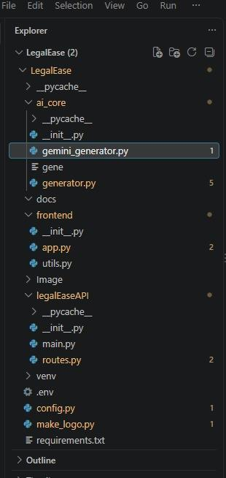
Screenshot: LegalEase project folder structure in VS Code Explorer, showing ai_core/, frontend/, legalEaseAPI/, Image/ and supporting files

15. Project Setup

15.1 Create a Virtual Environment
A virtual environment is created to provide an isolated Python environment for the LegalEase project.
Command: python -m venv venv

15.2 Activate the Virtual Environment
Windows Command: venv\Scripts\activate

15.3 Install Required Dependencies
Command: pip install -r requirements.txt
This installs FastAPI, Uvicorn, Streamlit, python-docx, fpdf2, Pillow, Requests, Google Generative AI, and python-dotenv.
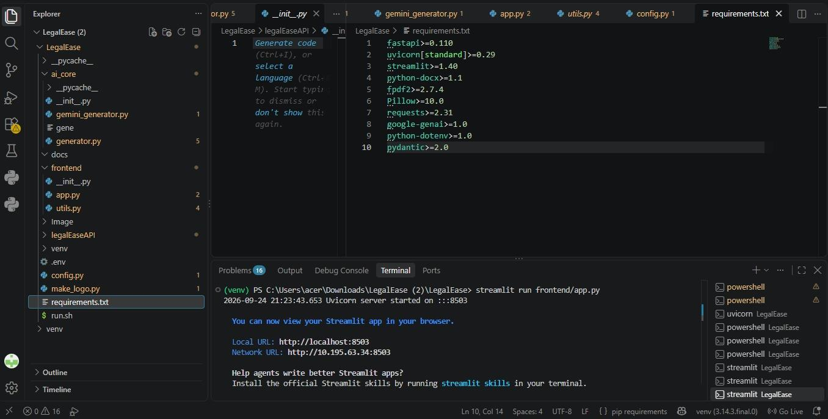
Screenshot: requirements.txt listing project dependencies, with the VS Code terminal confirming a successful Streamlit run

15.4 Configure Environment Variables
Rename .env.example to .env and add the Gemini API key.
GEMINI_API_KEY=your_actual_key_here
The API key is stored as an environment variable so that it can be used securely by the Gemini document generator.
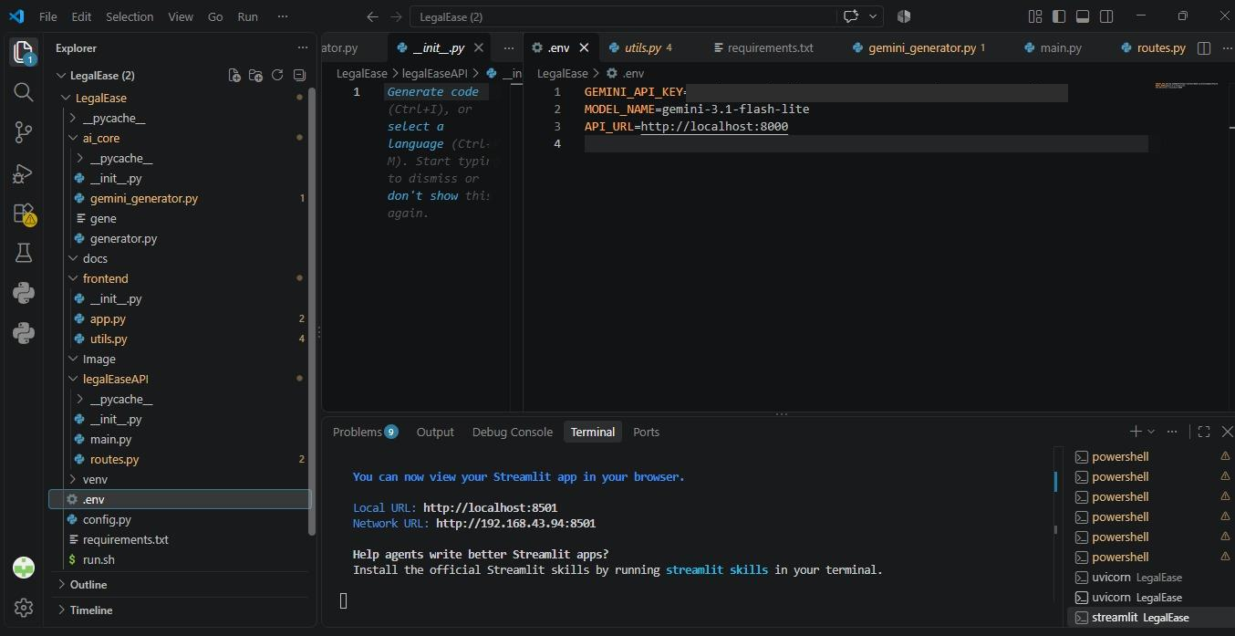
Screenshot: .env file configured with GEMINI_API_KEY, MODEL_NAME and API_URL

15.5 Add Application Logo
Place a PNG logo at Image/Logo.png. The application can still run without the logo.
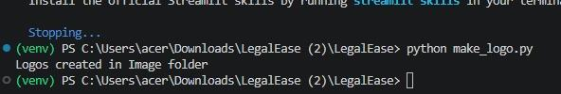
Screenshot: terminal output after running make_logo.py, confirming logos were created in the Image folder

16. Starting the Application

16.1 Start the Backend Server
Command: uvicorn legalEaseAPI.main:app --reload
The documented development address is http://127.0.0.1:8000.

16.2 Start the Frontend
Command: streamlit run frontend/app.py
The documented local address is http://localhost:8501.
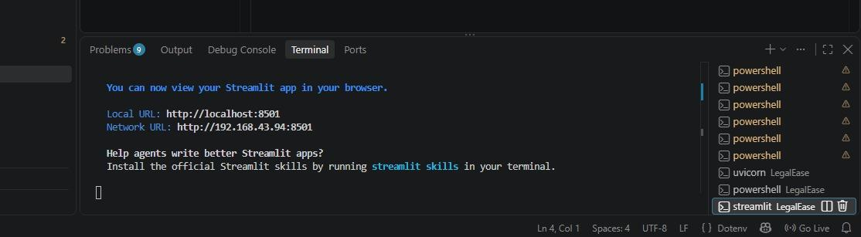
Screenshot: terminal confirming the Streamlit frontend is running, with the Local and Network URLs

17. API Endpoints

17.1 API Health Check
The FastAPI application includes a root endpoint that returns a welcome message for the LegalEase API.
GET /

17.2 Generate Legal Document
The frontend sends a POST request to the backend generation endpoint.
POST /generate
Request Fields
- document_type
- parties
- terms
- dates

API Response
The backend returns the generated document in a JSON response using the document field.

18. Backend Development

18.1 FastAPI Application
The main.py file creates the FastAPI application, includes the API router, and provides a root health-check endpoint. When executed directly, it can run the application using Uvicorn.

18.2 API Request Validation
The routes.py file defines the DocumentRequest Pydantic model. It validates the four input values required by the document-generation endpoint.

18.3 Generate Document Endpoint
The /generate POST endpoint receives a DocumentRequest object and calls GeminiDocumentGenerator.generate_document() with the supplied document details.

18.4 Error Handling
If an exception occurs while generating the document, the API raises an HTTP 500 response containing the error detail.

19. Backend Flow
- Receive POST request.
- Validate request using Pydantic.
- Pass document details to GeminiDocumentGenerator.
- Generate legal document using Gemini 1.5 Pro.
- Return generated text as JSON.
- Return HTTP 500 if an exception occurs.

20. AI Development

20.1 Gemini Document Generator
The GeminiDocumentGenerator class is implemented in ai_core/gemini_generator.py. It loads environment variables, checks for GEMINI_API_KEY, configures the Google Generative AI library, and initializes the Gemini 1.5 Pro model.
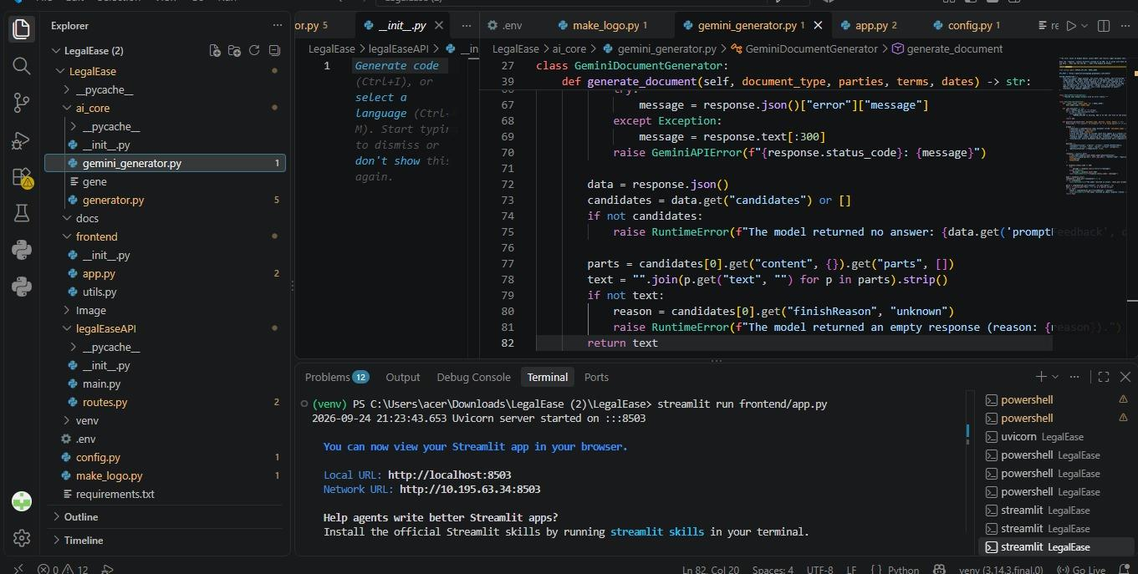
Screenshot: gemini_generator.py showing the GeminiDocumentGenerator class and its generate_document() method

20.2 Prompt Construction
The generator builds a structured prompt containing the document type, involved parties, effective date, and terms and conditions. It also requests a formal legal structure with multiple sections and legal clauses.

20.3 AI Generation Process
- Load GEMINI_API_KEY from the environment.
- Configure the Google Generative AI service.
- Initialize Gemini 1.5 Pro.
- Build the legal-document generation prompt.
- Call generate_content().
- Return the generated response text.

21. Frontend Development
The app.py file creates the LegalEase interface. It displays the logo when available, collects the required inputs, sends the request to the backend, and stores the generated document in Streamlit session state.
After generation, the document is shown inside a styled HTML preview. The user can toggle an editing area and modify the generated text before downloading it.
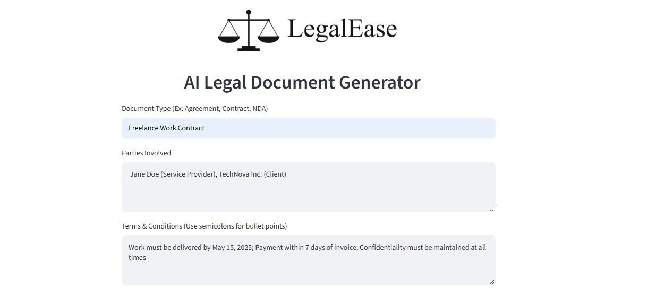
Screenshot: the LegalEase interface (AI Legal Document Generator) with Document Type, Parties Involved and Terms & Conditions fields

22. Document Formatting and Export

22.1 Text Sanitization
The sanitize_text() function replaces typographic quotation marks, dashes, and bullet characters with compatible ASCII characters. Remaining non-ASCII characters are removed to support the PDF font encoding used by the application.

22.2 DOCX Generation
- The format_docx() function creates a Word document.
- The document title is centered.
- The normal text style uses Times New Roman, 11 pt.
- Semicolon-separated terms can be rendered as a table.
- A LegalEase footer is added to the document.
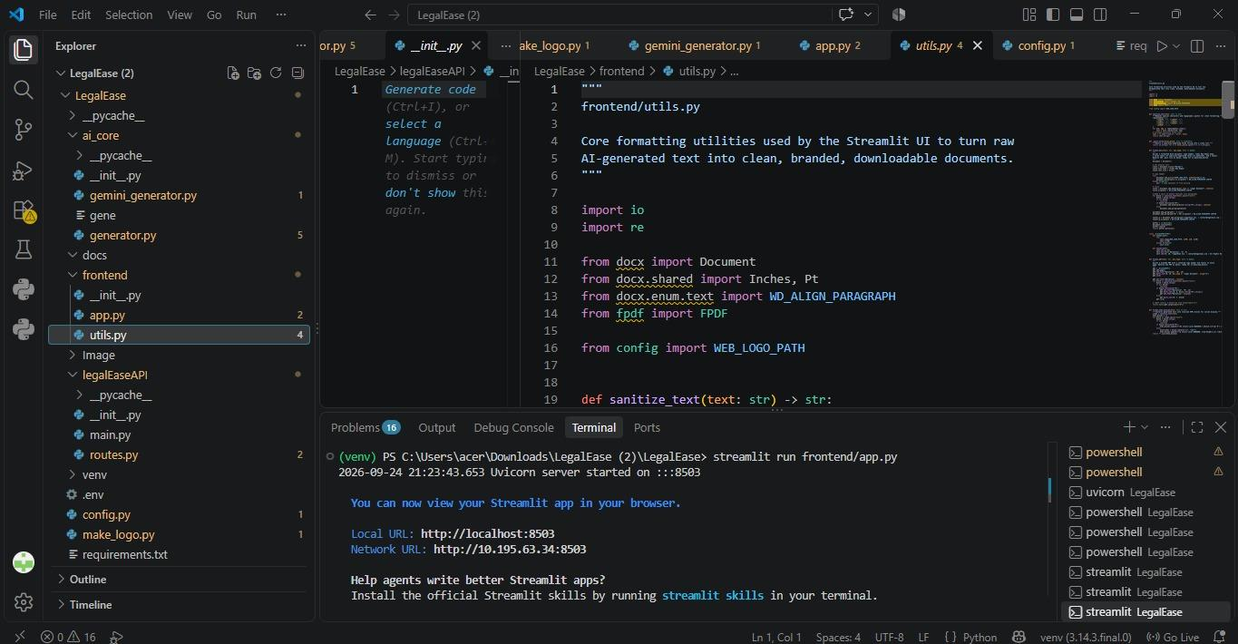
Screenshot: frontend/utils.py showing the formatting utilities used to build DOCX and PDF outputs

22.3 PDF Generation
- The format_pdf() function creates a PDF using fpdf2.
- The document title is centered using a Times font.
- Lines beginning with # are treated as headings.
- Semicolon-separated terms are rendered as bullet points.
- A LegalEase footer is added to the PDF.

22.4 HTML Preview
The format_html_preview() function converts line breaks into HTML breaks and displays the generated document inside a styled preview card in Streamlit.

23. Download Options
Format | Output
TXT | Plain text document
DOCX | Formatted Word document
PDF | Formatted PDF document

24. Project Execution
- Open the LegalEase project folder in VS Code.
- Create and activate the Python virtual environment.
- Install the required dependencies.
- Configure the GEMINI_API_KEY in the .env file.
- Start the FastAPI backend server.
- Start the Streamlit frontend.
- Enter document type, parties, terms, and effective date.
- Generate the legal document.
- Preview and edit the generated document if required.
- Download the final document as TXT, DOCX, or PDF.

25. Expected Project Output
The final output is an AI-generated legal document based on the information supplied by the user. The generated content is displayed in the LegalEase interface and can be edited before being exported.

26. Project Diagrams
The project includes the following supporting diagrams, maintained alongside the codebase for onboarding and review purposes:
- Figure 1: Project Architecture
- Figure 2: System Components
- Figure 3: User Flow

27. Sample Walkthrough: Input & Generated Output
This section demonstrates an end-to-end run of LegalEase, from filling the input form on the Streamlit UI (running locally at localhost:8501) to the AI-generated, editable, downloadable output.

27.1 Step 1 — Input Form
The user opens the LegalEase interface and fills in the four required fields.
Field | Sample Value
Document Type | Rental Agreement
Parties Involved | Ramesh (Landlord), Suresh (Tenant)
Terms & Conditions | Monthly rent is Rs. 15,000; Security deposit of Rs. 30,000 refundable; Agreement valid for 11 months; Either party may terminate with 30 days notice
Effective Date | 25-09-2026

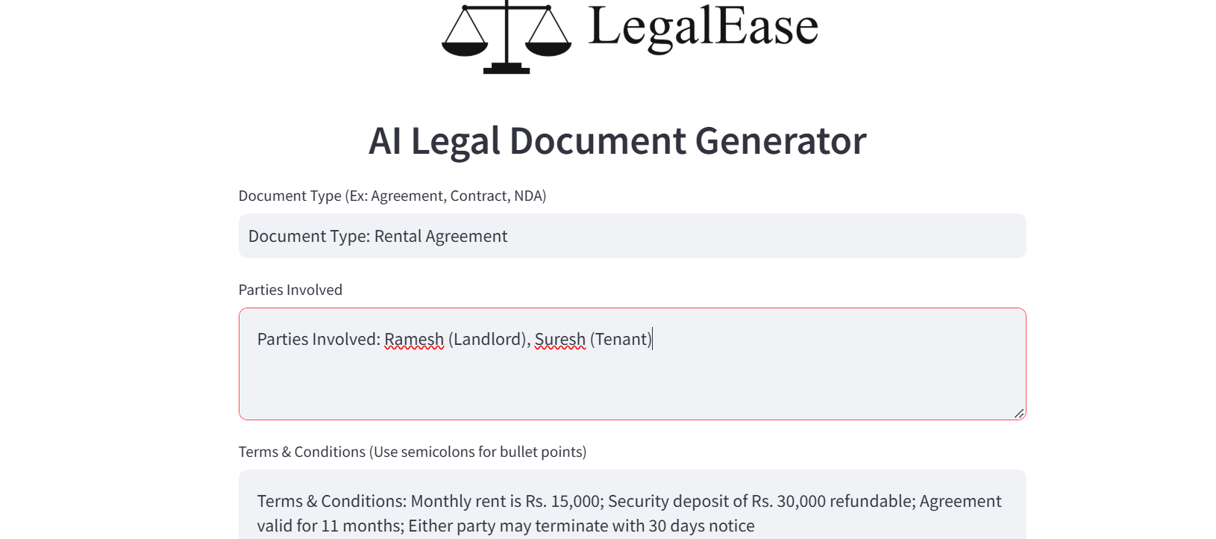
Screenshot: LegalEase input form with sample Rental Agreement data
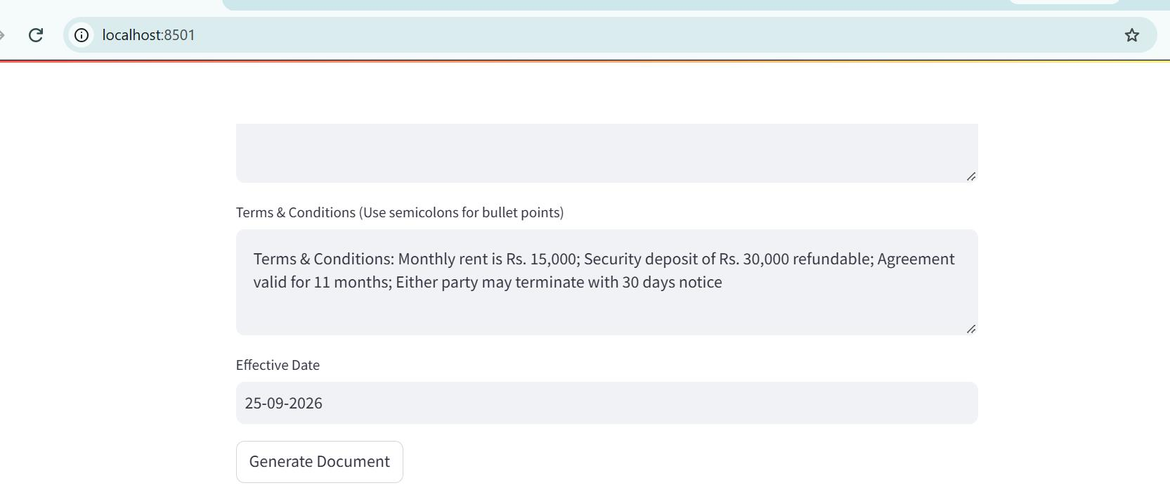
Screenshot: Terms & Conditions, Effective Date fields, and the Generate Document button (localhost:8501)

27.2 Step 2 — Generated Document Preview
On clicking Generate Document, the request is validated by Pydantic, sent to the Gemini document generator, and the AI-generated legal text is rendered in the styled HTML preview. The first clause of the generated Rental Agreement, along with the Edit and Download controls, is shown below.
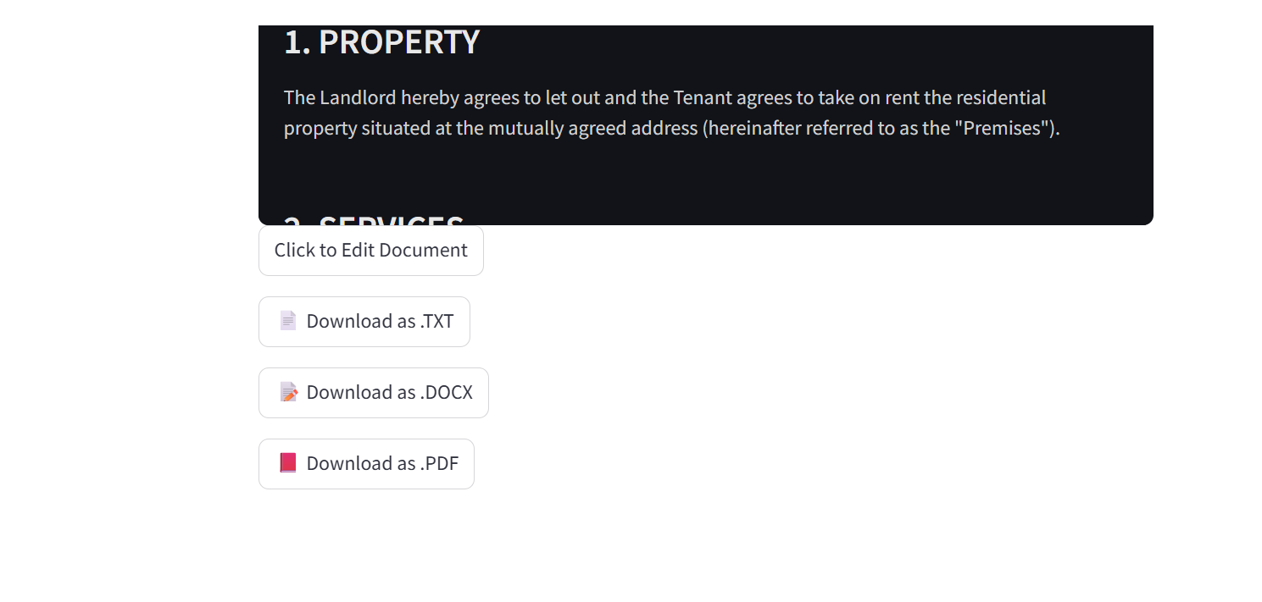
Screenshot: Generated document preview showing Clause 1 (Property), with Edit and Download controls

27.3 Step 3 — Edit and Download
Below the preview, LegalEase provides the following controls:
Control | Function
Click to Edit Document | Expands an inline text area so the user can revise the AI-generated content before exporting.
Download as .TXT | Exports the current document text as a plain .txt file.
Download as .DOCX | Exports a formatted Word document using format_docx() (Times New Roman, centered title, LegalEase footer).
Download as .PDF | Exports a formatted PDF using format_pdf() via fpdf2, with headings and bullet-styled terms.

27.4 Notes on the Sample Output
The clause text visible in the screenshot above ("The Landlord hereby agrees to let out and the Tenant agrees to take on rent the residential property situated at the mutually agreed address...") is genuine output captured from a live run of the application against the sample input in Section 27.1. It is shown here only to demonstrate document structure and formatting, and is not a substitute for review by a qualified legal professional before use in an actual tenancy.

28. Testing

28.1 Manual API Testing
The /generate endpoint can be exercised directly with curl or any REST client once the FastAPI backend is running:
curl -X POST http://127.0.0.1:8000/generate -H "Content-Type: application/json" -d "{\"document_type\": \"Rental Agreement\", \"parties\": \"Ramesh (Landlord), Suresh (Tenant)\", \"terms\": \"Monthly rent is Rs. 15,000; Security deposit of Rs. 30,000 refundable\", \"dates\": \"25-09-2026\"}"

28.2 Recommended Automated Checks
- Pydantic model tests for DocumentRequest, covering missing fields, empty strings, and invalid date formats.
- Unit tests for sanitize_text(), format_docx(), format_pdf() and format_html_preview() using known input/output pairs.
- Integration test for the /generate endpoint using FastAPI's TestClient, with the Gemini call mocked.
- Smoke test that boots the Streamlit app and confirms the form renders and submits without error.

29. Security Considerations and Limitations

29.1 Security Considerations
- The Gemini API key is kept out of source control via .env / .env.example and should never be committed or logged.
- User-supplied text (parties, terms) is passed into the AI prompt; input length and content should be validated to reduce prompt-injection risk before the prompt is sent to Gemini.
- The generated document may include user-entered personal or financial data (names, rent amounts); downloads should be treated as containing sensitive information.
- For any deployment beyond localhost, CORS, HTTPS, and rate limiting on the /generate endpoint are recommended but not yet implemented in the current version.

29.2 Known Limitations
- Generated documents are AI-drafted and are not reviewed by a licensed legal professional; they are a starting draft, not final legal advice.
- The system currently supports English-language input and output only.
- Document generation depends on the availability and rate limits of the Gemini 1.5 Pro API; no offline fallback exists.
- There is no persistent storage or document history — generated documents exist only in the current Streamlit session state unless downloaded.
- No user authentication or access control is implemented; the application is intended for local/single-user use in its current form.

30. Deployment Notes
The current documentation covers local execution only (FastAPI on 127.0.0.1:8000, Streamlit on localhost:8501). For a shared or production deployment, the following are suggested next steps:
- Containerize the backend and frontend separately with Docker, using a docker-compose.yml to run both services together.
- Deploy the FastAPI backend behind a production ASGI server (Uvicorn with Gunicorn workers) on a platform such as Render, Railway, or AWS.
- Serve the Streamlit frontend via Streamlit Community Cloud or a container on the same platform as the backend.
- Move GEMINI_API_KEY and other secrets into the hosting platform's secret manager instead of a local .env file.
- Add HTTPS termination, CORS restrictions, and basic request rate-limiting in front of the /generate endpoint.

31. Future Enhancements
- Multi-language document generation and localization.
- User accounts with saved document history and templates.
- Digital / e-signature integration for finalized documents.
- Clause-level version comparison when a document is edited.
- Support for additional export formats (e.g., ODT, HTML).
- Optional human legal-review workflow before final download.

32. Conclusion
LegalEase combines a Streamlit frontend, FastAPI backend, and Gemini 1.5 Pro to provide an AI-assisted legal document generation workflow. Its modular structure separates the user interface, API layer, AI generation logic, and document-formatting utilities, making the project organized and easier to manage.

33. Final Workflow
USER INPUT → STREAMLIT → FASTAPI → PYDANTIC VALIDATION → GEMINI 1.5 PRO → GENERATED LEGAL DOCUMENT → PREVIEW / EDIT → TXT / DOCX / PDF

34. Document Information
Field | Detail
Project | LegalEase — AI Legal Document Generator
Maintainer | LegalEase Inc.
Documentation Version | 2.0 (Revised & Expanded)
Last Updated | September 25, 2026

35. Project Repository
Project Repository Link: https://github.com/<your-username>/LegalEase

